**Unearthing the Environmental Impact of Human Activity:**

**A Global CO2 Emission Analysis**

**PROJECT REPORT**

**INTRODUCTION**

* 1. **Overview**

Global warming is one of the biggest challenges currently being faced by the human race, although correlation is not causation, a likely cause of global warming is due to increased atmospheric carbon dioxide from human activities. CO2 Emission refers to the Carbon Dioxide emitted throughout the world. For this analysis we will be focusing on CO2 Emissions and its effect on the world we live in as well as some key factors and stats that may play a role in the emission of CO2 globally. Fossil fuel use is the primary source of CO2. The data throws light onto how much fossil fuels are burnt, per year per nation, which amounts to an increase in CO2 every year. This will help researchers and environment experts to predict global warming. So countries should set a goal to decrease this amount yearly. Analysing Global Co2 Emission across countries from 1975 to 2020. This dataset contains a record of Co2 Emission by each Country and Region of Earth, here we are going to analyse and visualise Country wise, Region wise and Overall Co2 Emission on Earth**.**

* 1. **Purpose**

The purpose of this project is to conduct a comprehensive analysis of global CO2 emissions from human activities, with a focus on understanding the environmental impact of these emissions and their contribution to global warming. The project aims to provide insights and data-driven evidence on the trends and patterns of CO2 emissions across countries and regions from 1975 to 2020, highlighting the key factors and statistics that play a role in the emission of CO2. The ultimate goal is to raise awareness about the urgent need to reduce CO2 emissions and support policy-making efforts to mitigate climate change by setting emission reduction goals at the national and global levels. The analysis and visualization of CO2 emission data can serve as a valuable resource for researchers, environmental experts, policymakers, and other stakeholders working towards addressing the global challenge of climate change.

Quantify and compare the CO2 emissions of different countries and regions over time: The project can provide a comprehensive analysis of CO2 emissions by country and region, highlighting the historical trends, patterns, and changes in emissions levels from 1975 to 2020. This can help identify countries and regions that are major contributors to global CO2 emissions and track their progress in emission reduction efforts.

Identify key sectors and activities driving CO2 emissions: The project can analyze the sectors and activities that are major sources of CO2 emissions, such as energy production, transportation, industrial processes, and deforestation. This can provide insights into the main drivers of CO2 emissions and help prioritize efforts and policies to target these sectors for emissions reduction.

Assess the impact of CO2 emissions on global warming: The project can examine the correlation between CO2 emissions and global warming, using scientific evidence and data. This can help establish the link between human activities and climate change, emphasizing the urgent need to reduce CO2 emissions to mitigate the adverse effects of global warming on the environment and society.

Raise awareness and promote action on climate change: The project can serve as a tool for raising public awareness about the severity of the climate change issue and the role of CO2 emissions in exacerbating it. By visualizing and presenting the data in an accessible and engaging manner, the project can help educate and engage a wider audience, including policymakers, businesses, and the general public, to take action towards reducing CO2 emissions and addressing climate change.

Support policy-making and decision-making processes: The project can provide evidence-based insights to support policy-making and decision-making processes at the national and global levels. Policymakers can use the findings of the analysis to inform the development and implementation of effective policies, regulations, and strategies to reduce CO2 emissions and transition towards a more sustainable and low-carbon future.

**PROBLEM DEFINITION & DESIGN THINKING**

**2.1 Empathy Map**

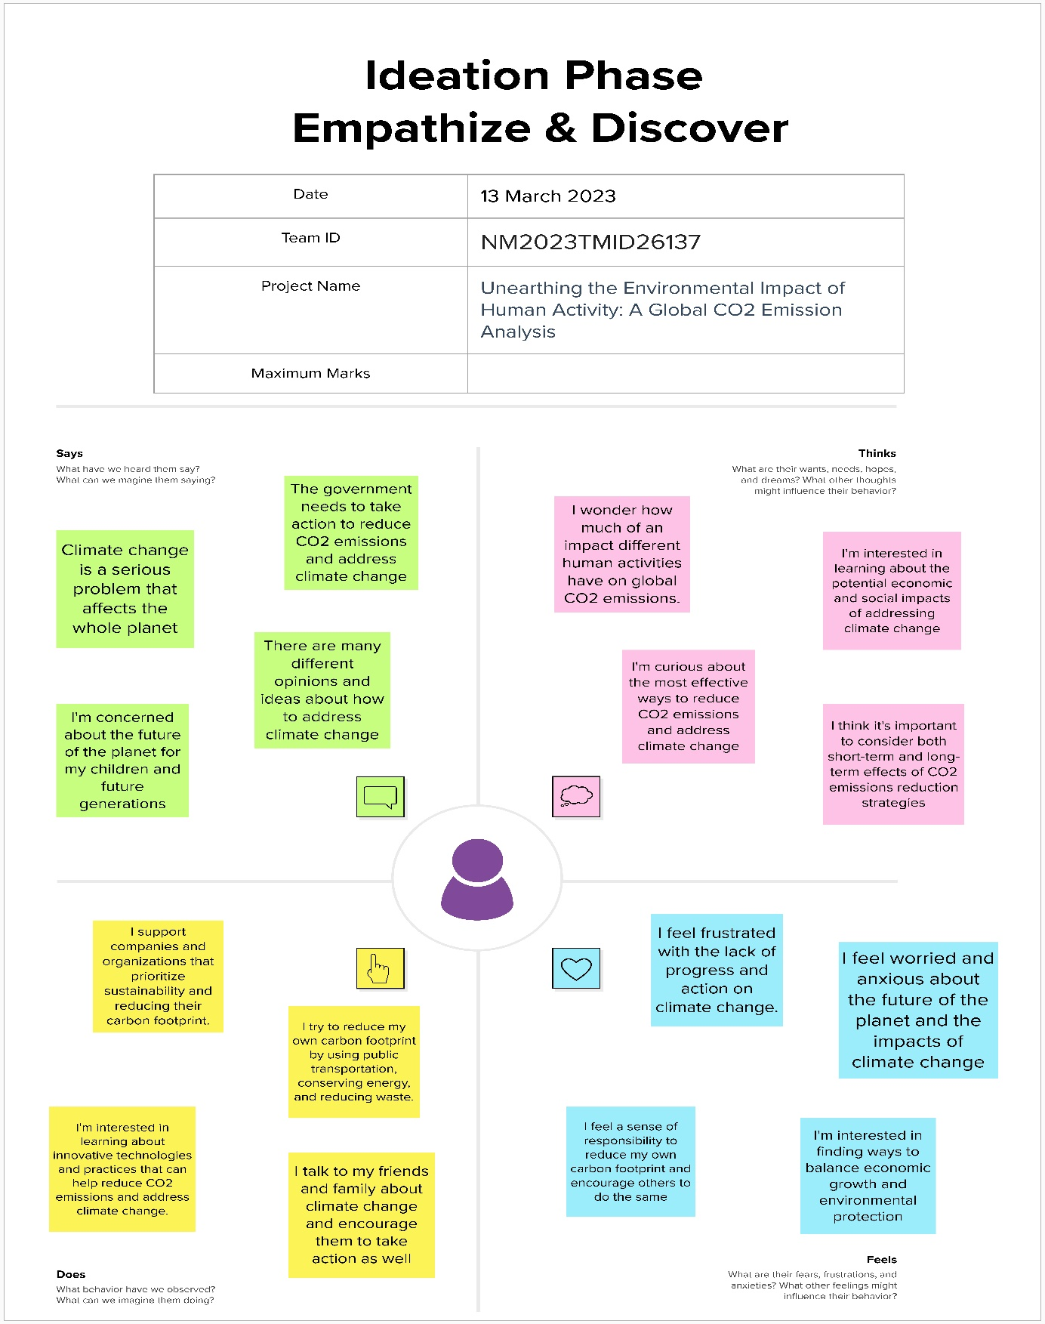

**2.2 Ideation & Brainstorming Map**

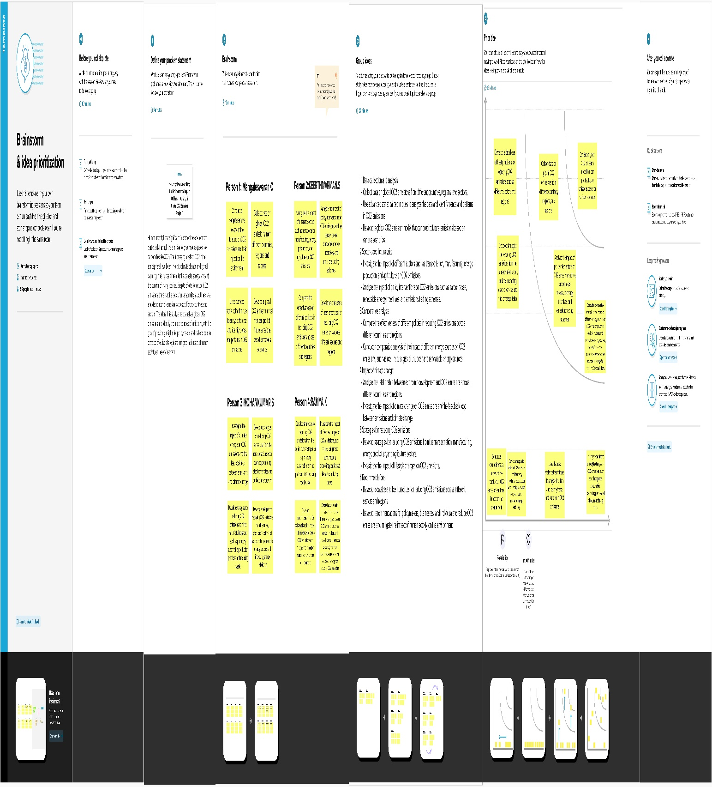

**RESULT**

**Screenshots of output:**

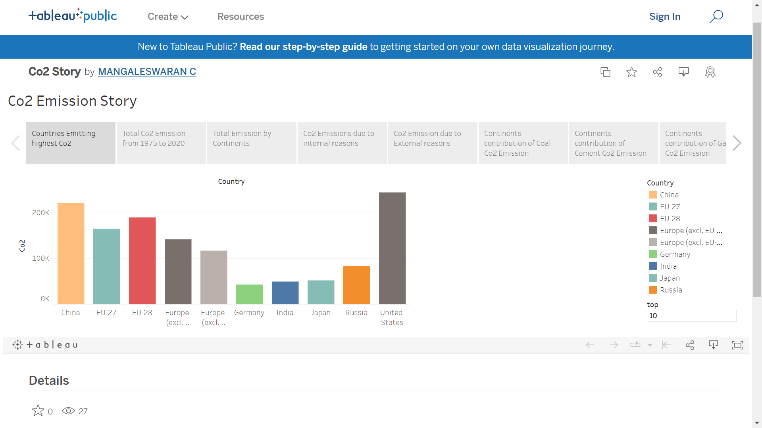

**Fig3.1 Story webpage**

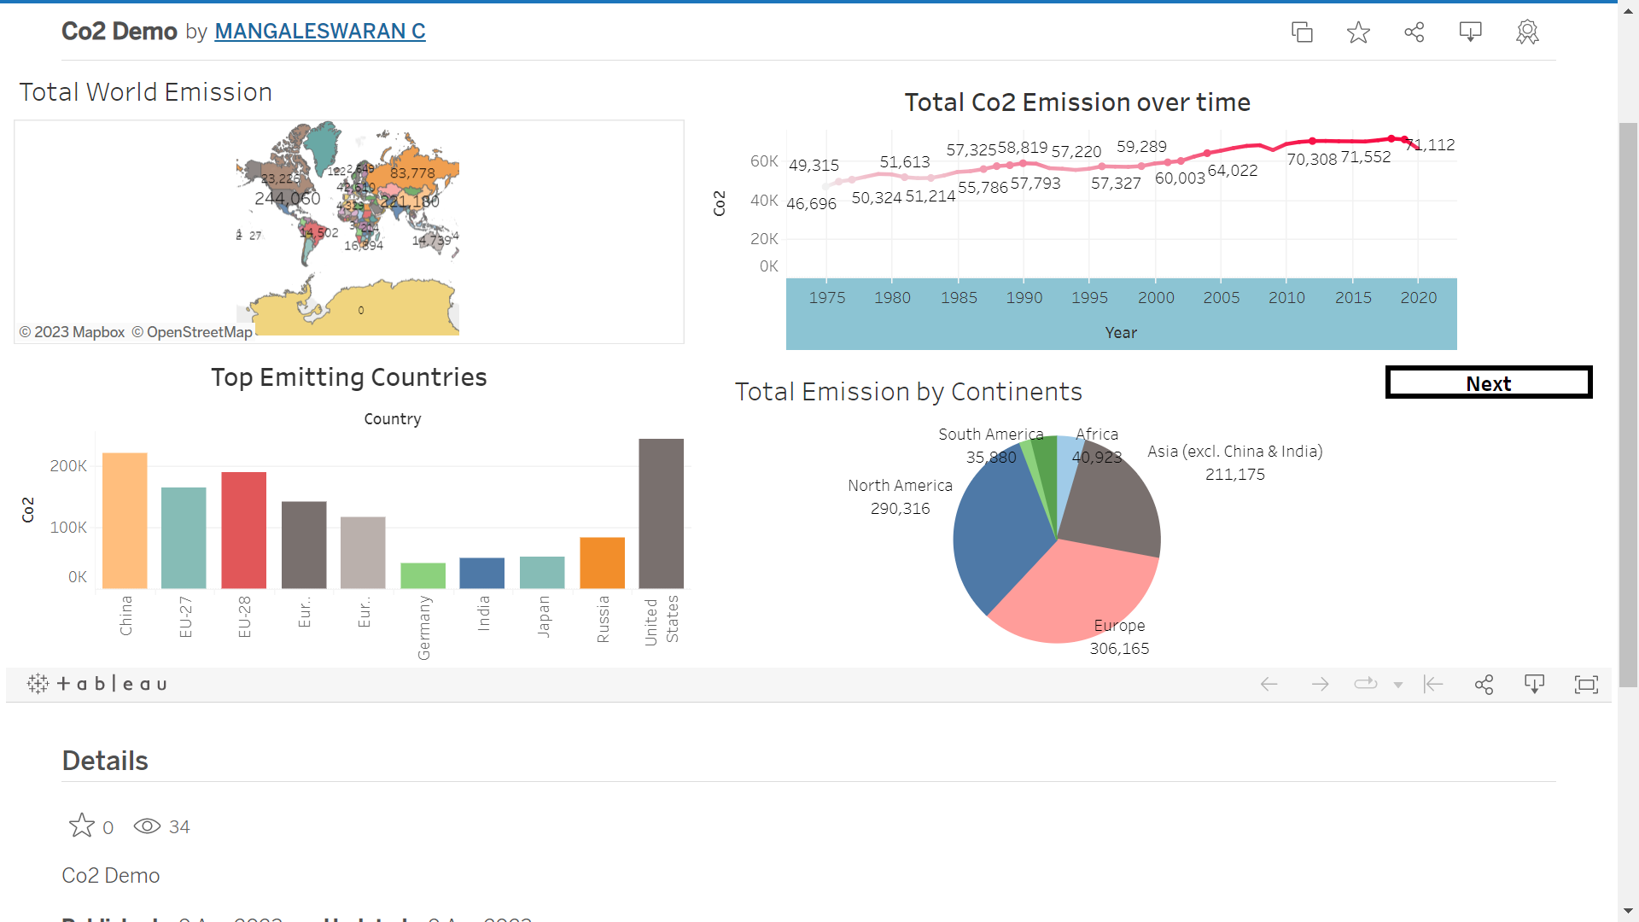

**Fig 3.2 Dashboard webpage**

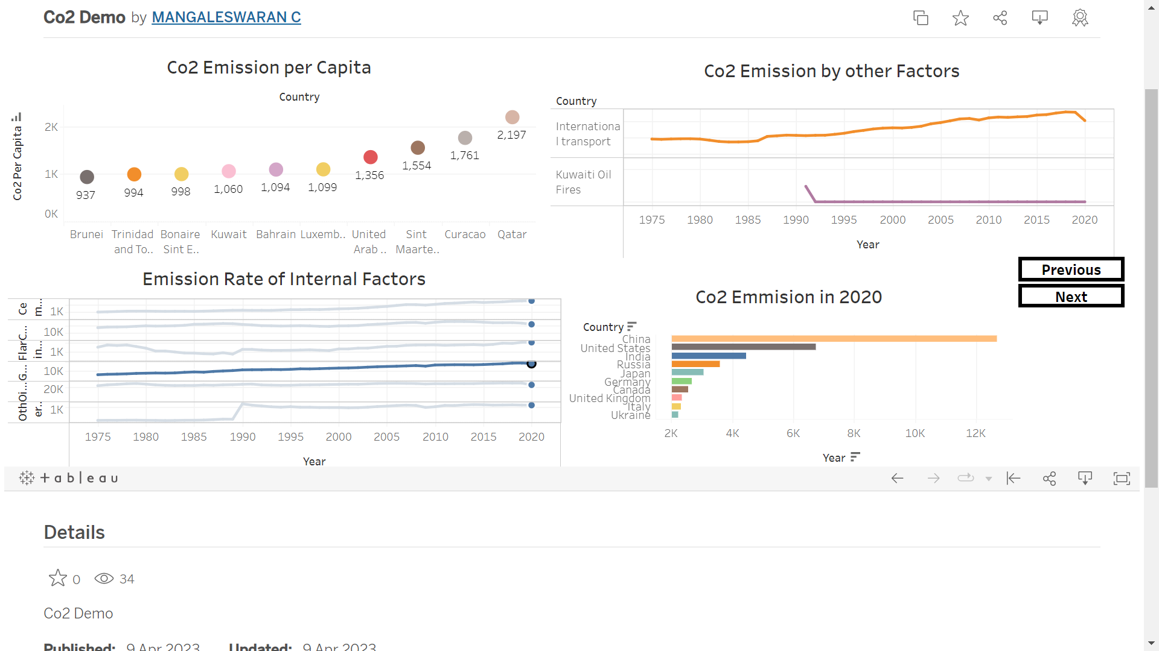

**Fig 3.3 Dashboard webpage**

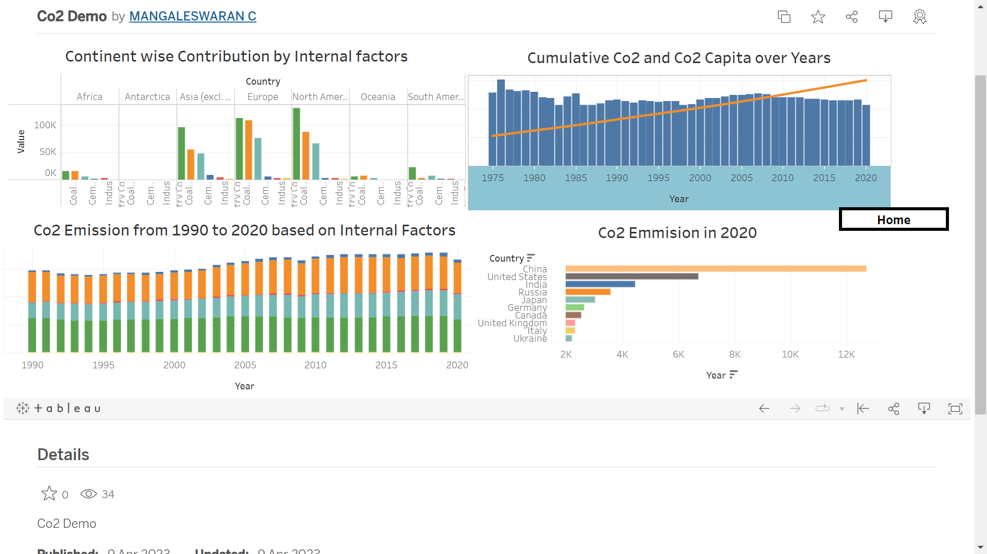

**Fig 3.4 Dashboard webpage**

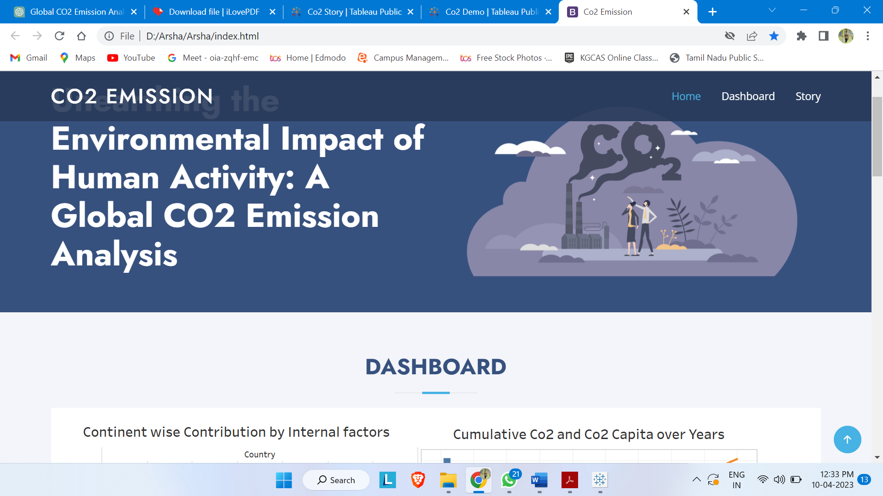

**Fig 3.5 Webpage of the project**

**ADVANTAGES & DISADVANTAGES**

**Advantages:**

1. Increased awareness: The project can raise awareness about the severity of the climate change issue and the role of CO2 emissions in contributing to global warming. It can help educate and engage a wider audience, including policymakers, businesses, and the general public, about the urgency of reducing CO2 emissions and addressing climate change.
2. Data-driven insights: The project can provide valuable data-driven insights on historical trends and patterns of CO2 emissions across countries and regions. This can inform policy-making processes, help identify key sectors driving emissions, and support evidence-based decision-making for emissions reduction strategies.
3. Policy support: The project can contribute to policy-making efforts by providing evidence to support the development and implementation of effective policies, regulations, and strategies to reduce CO2 emissions. It can serve as a resource for policymakers to understand the current status of emissions, identify high-emitting countries and regions, and set emission reduction targets.
4. Global perspective: The project can provide a global perspective on CO2 emissions, covering multiple countries and regions. This can help identify countries and regions that are major contributors to global emissions, highlight regional disparities, and foster international cooperation and coordination in addressing climate change.

**Disadvantages:**

1. Data limitations: The project's analysis and findings are dependent on the availability and quality of data on CO2 emissions, which may vary across countries and regions. Data gaps, inconsistencies, and inaccuracies can limit the accuracy and reliability of the analysis and conclusions.
2. Complexities of emissions attribution: Attribution of emissions to specific countries or regions can be complex due to factors such as international trade, carbon leakage, and differences in emission accounting methodologies. This can introduce uncertainties in the analysis and interpretation of emissions data.
3. Ethical considerations: The project may need to consider ethical considerations, such as data privacy, data ownership, and potential biases in data collection and analysis. Ensuring that the project adheres to ethical principles and guidelines is important to maintain integrity and credibility.
4. Limited impact: While the project can raise awareness and provide valuable insights, its impact on actual emissions reduction may be limited. Implementation of emissions reduction policies and measures requires concerted efforts from governments, businesses, and individuals, and may face challenges related to political, economic, and social factors.
5. Incomplete scope: The project may focus on CO2 emissions as a primary greenhouse gas, but other greenhouse gases such as methane, nitrous oxide, and fluorinated gases also contribute to climate change. The project's scope may be limited in capturing the full spectrum of greenhouse gas emissions and their impacts on global warming.

It's important to consider these advantages and disadvantages in planning and conducting the project, and to address any limitations to ensure the accuracy, integrity, and impact of the analysis and findings.

**APPLICATIONS**

There are several potential applications for the project on global CO2 emission analysis:

1. Policy-making: The project can provide data-driven insights that can inform the development and implementation of policies, regulations, and strategies to reduce CO2 emissions. It can help policymakers identify high-emitting countries and regions, set emission reduction targets, and evaluate the effectiveness of existing policies.
2. Climate change mitigation efforts: The project can contribute to global efforts to mitigate climate change by providing information on historical trends and patterns of CO2 emissions. This can help prioritize mitigation measures, identify sectors with the highest emissions, and support decision-making on emission reduction strategies at the national and regional levels.
3. International cooperation: The project can foster international cooperation and coordination in addressing climate change by providing a global perspective on CO2 emissions. It can facilitate dialogues, negotiations, and collaborations among countries and regions to collectively tackle the issue of global warming and reduce emissions.
4. Environmental advocacy: The project can serve as a tool for environmental advocacy by raising awareness about the severity of the climate change issue and the role of CO2 emissions in driving global warming. It can be used to engage and mobilize various stakeholders, including policymakers, businesses, civil society organizations, and the public, to take action on reducing emissions and mitigating climate change.
5. Education and outreach: The project can be used for educational purposes to increase understanding about the environmental impact of human activity, particularly CO2 emissions, and their contribution to global warming. It can be utilized in educational institutions, workshops, seminars, and public outreach programs to promote environmental literacy and awareness.
6. Business and industry decision-making: The project can provide insights to businesses and industries on global CO2 emissions, helping them understand their own emissions footprint and identify opportunities for emissions reduction measures. This can support decision-making on sustainable business practices, corporate social responsibility, and carbon management strategies.
7. Research and innovation: The project can serve as a resource for researchers and innovators to analyze global CO2 emissions data and identify trends, patterns, and correlations. It can contribute to the advancement of knowledge in the field of climate change, emissions modeling, and mitigation strategies, and support the development of innovative solutions to address the issue.

Overall, the project on global CO2 emission analysis has potential applications in policy-making, climate change mitigation efforts, international cooperation, environmental advocacy, education and outreach, business decision-making, and research and innovation, among others.

**CONCLUSION**

In conclusion, the analysis of global CO2 emissions data can provide valuable insights into the environmental impact of human activities and its contribution to global warming. The project has several advantages, including the ability to inform policy-making, support climate change mitigation efforts, foster international cooperation, advocate for environmental awareness, facilitate education and outreach, aid business decision-making, and promote research and innovation.

By analyzing CO2 emissions data from different countries and regions over time, the project can help identify trends, patterns, and correlations that can guide actions towards reducing emissions and mitigating climate change. It can provide evidence-based information to policymakers, businesses, civil society organizations, and the public to make informed decisions and take necessary actions to address the pressing issue of global warming.

However, the project also has limitations, including potential data gaps, limitations in data accuracy or reliability, and challenges in data collection and analysis. It is important to acknowledge these limitations and interpret the findings with caution, considering the complexities and uncertainties associated with CO2 emissions and climate change.

In summary, the project on global CO2 emission analysis has significant potential for generating valuable insights, informing decision-making, and contributing to global efforts to mitigate climate change. It can support actions at the local, national, regional, and global levels to reduce emissions, promote sustainable practices, and protect the environment for current and future generations.

**FUTURE SCOPE**

The future scope of the project on global CO2 emission analysis can be expanded in several ways, including:

1. Long-term trend analysis: The project can continue to analyze and monitor global CO2 emissions over an extended period, tracking long-term trends, patterns, and changes in emission levels. This can provide valuable insights into the effectiveness of emission reduction policies and strategies, and help identify emerging trends and challenges in addressing climate change.
2. Spatial analysis: The project can incorporate spatial analysis techniques to analyze CO2 emissions data at finer geographic scales, such as regional, city, or even local levels. This can provide a more detailed understanding of emission hotspots, spatial patterns of emissions, and localized impacts of human activities on the environment.
3. Sector-specific analysis: The project can delve deeper into specific sectors that are major contributors to CO2 emissions, such as energy production, transportation, industry, and agriculture. This can provide sector-specific insights, identifying opportunities for emissions reductions, and supporting targeted interventions and policies in high-emitting sectors.
4. Comparative analysis: The project can expand its scope by comparing CO2 emissions data across different countries, regions, and time periods. This can help identify best practices, success stories, and lessons learned from different regions and countries in reducing emissions, and facilitate knowledge sharing and mutual learning among stakeholders.
5. Integrated assessment modeling: The project can integrate CO2 emissions data with other environmental, social, and economic data to develop integrated assessment models that can assess the complex interactions and impacts of human activities on the environment and society. This can provide a holistic and comprehensive understanding of the drivers of CO2 emissions, their consequences, and potential policy interventions.
6. Scenario analysis: The project can explore different scenarios and projections of future CO2 emissions based on different assumptions and scenarios, such as population growth, economic development, technological advancements, and policy changes. This can help policymakers and stakeholders in evaluating the potential impacts of different scenarios and designing effective strategies for emissions reductions in the future.
7. Innovations in data collection and analysis: The project can explore innovative approaches and technologies for data collection, analysis, and visualization, such as machine learning, remote sensing, big data analytics, and interactive data visualization tools. This can enhance the accuracy, timeliness, and accessibility of CO2 emissions data, and facilitate more advanced and sophisticated analyses.

Overall, the future scope of the project on global CO2 emission analysis is vast and can be expanded in various ways to deepen our understanding of the environmental impact of human activities, support evidence-based policy-making, and contribute to global efforts to mitigate climate change. As technology advances and more data becomes available, the project can continue to evolve and provide valuable insights for addressing one of the most pressing challenges of our time - global warming caused by CO2 emissions.

**APPENDIXTop of Form**

**SOURCE CODE:**

<!DOCTYPE html>

<html lang="en">

<head>

<meta charset="utf-8">

<meta content="width=device-width, initial-scale=1.0" name="viewport">

<title>Co2 Emission</title>

<meta content="" name="description">

<meta content="" name="keywords">

<!-- Favicons -->

<link href="assets/img/favicon.png" rel="icon">

<link href="assets/img/apple-touch-icon.png" rel="apple-touch-icon">

<!-- Google Fonts -->

<link href="https://fonts.googleapis.com/css?family=Open+Sans:300,300i,400,400i,600,600i,700,700i|Jost:300,300i,400,400i,500,500i,600,600i,700,700i|Poppins:300,300i,400,400i,500,500i,600,600i,700,700i" rel="stylesheet">

<!-- Vendor CSS Files -->

<link href="assets/vendor/aos/aos.css" rel="stylesheet">

<link href="assets/vendor/bootstrap/css/bootstrap.min.css" rel="stylesheet">

<link href="assets/vendor/bootstrap-icons/bootstrap-icons.css" rel="stylesheet">

<link href="assets/vendor/boxicons/css/boxicons.min.css" rel="stylesheet">

<link href="assets/vendor/glightbox/css/glightbox.min.css" rel="stylesheet">

<link href="assets/vendor/remixicon/remixicon.css" rel="stylesheet">

<link href="assets/vendor/swiper/swiper-bundle.min.css" rel="stylesheet">

<!-- Template Main CSS File -->

<link href="assets/css/style.css" rel="stylesheet">

<!-- =======================================================

* Template Name: Arsha

* Updated: Mar 10 2023 with Bootstrap v5.2.3

* Template URL: https://bootstrapmade.com/arsha-free-bootstrap-html-template-corporate/

* Author: BootstrapMade.com

* License: https://bootstrapmade.com/license/

======================================================== -->

</head>

<body>

<!-- ======= Header ======= -->

<header id="header" class="fixed-top ">

<div class="container d-flex align-items-center">

<h1 class="logo me-auto"><a href="index.html">Co2 Emission</a></h1>

<!-- Uncomment below if you prefer to use an image logo -->

<!-- <a href="index.html" class="logo me-auto"><img src="assets/img/logo.png" alt="" class="img-fluid"></a>-->

<nav id="navbar" class="navbar">

<ul>

<li><a class="nav-link scrollto active" href="#hero">Home</a></li>

<li><a class="nav-link scrollto" href="#services">Dashboard</a></li>

<li><a class="nav-link scrollto" href="#portfolio">Story</a></li>

</ul>

<i class="bi bi-list mobile-nav-toggle"></i>

</nav><!-- .navbar -->

</div>

</header><!-- End Header -->

<!-- ======= Hero Section ======= -->

<section id="hero" class="d-flex align-items-center">

<div class="container">

<div class="row">

<div class="col-lg-6 d-flex flex-column justify-content-center pt-4 pt-lg-0 order-2 order-lg-1" data-aos="fade-up" data-aos-delay="200">

<h1>Unearthing the Environmental Impact of Human Activity: A Global CO2 Emission Analysis</h1>

</div>

<div class="col-lg-6 order-1 order-lg-2 hero-img" data-aos="zoom-in" data-aos-delay="200">

<img src="https://cdni.iconscout.com/illustration/premium/thumb/co2-emissions-as-dangerous-carbon-dioxide-5755922-4805221.png" class="img-fluid animated" alt="">

</div>

</div>

</div>

</section><!-- End Hero -->

<main id="main">

<!-- ======= Services Section ======= -->

<section id="services" class="services section-bg">

<div class="container" data-aos="fade-up">

<div class="section-title">

<h2>Dashboard</h2>

<div class='tableauPlaceholder' id='viz1681031336991' style='position: relative'><noscript><a href='#'><img alt=' ' src='https:&#47;&#47;public.tableau.com&#47;static&#47;images&#47;Co&#47;Co2Demo_16810299275880&#47;Dash3&#47;1_rss.png' style='border: none' /></a></noscript><object class='tableauViz' style='display:none;'><param name='host_url' value='https%3A%2F%2Fpublic.tableau.com%2F' /> <param name='embed_code_version' value='3' /> <param name='site_root' value='' /><param name='name' value='Co2Demo_16810299275880&#47;Dash3' /><param name='tabs' value='no' /><param name='toolbar' value='yes' /><param name='static_image' value='https:&#47;&#47;public.tableau.com&#47;static&#47;images&#47;Co&#47;Co2Demo_16810299275880&#47;Dash3&#47;1.png' /> <param name='animate_transition' value='yes' /><param name='display_static_image' value='yes' /><param name='display_spinner' value='yes' /><param name='display_overlay' value='yes' /><param name='display_count' value='yes' /><param name='language' value='en-GB' /><param name='filter' value='publish=yes' /></object></div> <script type='text/javascript'> var divElement = document.getElementById('viz1681031336991'); var vizElement = divElement.getElementsByTagName('object')[0]; if ( divElement.offsetWidth > 800 ) { vizElement.style.width='100%';vizElement.style.height=(divElement.offsetWidth*0.75)+'px';} else if ( divElement.offsetWidth > 500 ) { vizElement.style.width='100%';vizElement.style.height=(divElement.offsetWidth*0.75)+'px';} else { vizElement.style.width='100%';vizElement.style.height='1277px';} var scriptElement = document.createElement('script'); scriptElement.src = 'https://public.tableau.com/javascripts/api/viz_v1.js'; vizElement.parentNode.insertBefore(scriptElement, vizElement); </script>

<!-- ======= Portfolio Section ======= -->

<section id="portfolio" class="portfolio">

<div class="container" data-aos="fade-up">

<div class="section-title">

<h2>Story</h2>

</div>

<div class='tableauPlaceholder' id='viz1681031566769' style='position: relative'><noscript><a href='#'><img alt='Co2 Emission Story ' src='https:&#47;&#47;public.tableau.com&#47;static&#47;images&#47;NZ&#47;NZD4WWSMF&#47;1_rss.png' style='border: none' /></a></noscript><object class='tableauViz' style='display:none;'><param name='host_url' value='https%3A%2F%2Fpublic.tableau.com%2F' /> <param name='embed_code_version' value='3' /> <param name='path' value='shared&#47;NZD4WWSMF' /> <param name='toolbar' value='yes' /><param name='static_image' value='https:&#47;&#47;public.tableau.com&#47;static&#47;images&#47;NZ&#47;NZD4WWSMF&#47;1.png' /> <param name='animate_transition' value='yes' /><param name='display_static_image' value='yes' /><param name='display_spinner' value='yes' /><param name='display_overlay' value='yes' /><param name='display_count' value='yes' /><param name='language' value='en-GB' /><param name='filter' value='publish=yes' /></object></div> <script type='text/javascript'> var divElement = document.getElementById('viz1681031566769'); var vizElement = divElement.getElementsByTagName('object')[0]; vizElement.style.width='100%';vizElement.style.height=(divElement.offsetWidth*0.75)+'px'; var scriptElement = document.createElement('script'); scriptElement.src = 'https://public.tableau.com/javascripts/api/viz_v1.js'; vizElement.parentNode.insertBefore(scriptElement, vizElement); </script>

</section><!-- End Portfolio Section -->

</main><!-- End #main -->

<!-- ======= Footer ======= -->

<footer id="footer">

<div class="container footer-bottom clearfix">

<div class="copyright">

&copy; Copyright <strong><span>Arsha</span></strong>. All Rights Reserved

</div>

<div class="credits">

<!-- All the links in the footer should remain intact. -->

<!-- You can delete the links only if you purchased the pro version. -->

<!-- Licensing information: https://bootstrapmade.com/license/ -->

<!-- Purchase the pro version with working PHP/AJAX contact form: https://bootstrapmade.com/arsha-free-bootstrap-html-template-corporate/ -->

Designed by <a href="https://bootstrapmade.com/">BootstrapMade</a>

</div>

</div>

</footer><!-- End Footer -->

<div id="preloader"></div>

<a href="#" class="back-to-top d-flex align-items-center justify-content-center"><i class="bi bi-arrow-up-short"></i></a>

<!-- Vendor JS Files -->

<script src="assets/vendor/aos/aos.js"></script>

<script src="assets/vendor/bootstrap/js/bootstrap.bundle.min.js"></script>

<script src="assets/vendor/glightbox/js/glightbox.min.js"></script>

<script src="assets/vendor/isotope-layout/isotope.pkgd.min.js"></script>

<script src="assets/vendor/swiper/swiper-bundle.min.js"></script>

<script src="assets/vendor/waypoints/noframework.waypoints.js"></script>

<script src="assets/vendor/php-email-form/validate.js"></script>

<!-- Template Main JS File -->

<script src="assets/js/main.js"></script>

</body>

</html>

By using the above code, we can create a webpage.